# Academic Warehouse

**A Report submitted**

by

**Yaadvi Batra (170109007)**

# Chiragh Arora(170109009)

**Vishakha Gupta (170109037)**

**Poonam Lega(170109045)**

**Under the Guidance of**

**Mr. Manish Sharma IBM**

**Faculty**

**(CSE Department)**



In partial fulfilment of the requirements for the Degree of

# BACHELOR OF TECHNOLOGY

**in**

# COMPUTER SCIENCE & ENGINEERING,

DIT UNIVERSITY, DEHRADUN

(State Private University through State Legislature Act No. 10 of 2013 of Uttarakhand and approved by UGC)

# Mussoorie Diversion Road, Dehradun, Uttarakhand - 248009, India.

### DECLARATION

I hereby certify that the work, which is being presented in the report/ project report, entitled **Academic Warehouse**, in partial fulfilment of the requirement for the award of the Degree of **Bachelor of Technology** and submitted to the university is an authentic record of my/our work carried out during the period *September’20* to *November’20* under the supervision of Mr. Manish Sharma.

Chiragh Arora

Vishakha Gupta

Poonam Lega

Yaadvi Batra

Date: 22.10.2020

This is to certify that the above statement made by the candidate is correct to the best of my /our knowledge.

Date: 22.10..20 Mentor: Mr. Manish Sharm

# ACKNOWLEDGEMENT

We have immense pleasure in presenting the report for our project entitled **Academic Warehouse (University Management System)**

We would like to take this opportunity to express our gratitude to several people who have been sources of help & encouragement during this project.

We are very grateful and indebted to our project guide Mr Manish Sharma for providing their enduring patience, guidance & invaluable suggestions. They were the one who never let our morale down & always supported us through our thick & thin. They were the constant source of inspiration for us & took the utmost interest in our project.

We would also like to thank all the staff members for their invaluable co-operation & permitting us to work in the computer lab.

We are also thankful to all the students for giving us their useful advice & immense co-operation. Their support made the working of this project very pleasant.

# ABSTRACT

**Academic Warehouse (A University Management System)** deals with the maintenance of university, college, faculty, student information within the university. AW is an automation system, which is used to store the college, faculty, student, courses and information of a college.

Starting from registration of a new student in the college, it maintains all the details regarding the attendance assignment, notes and marks of the students. The project deals with the retrieval of information through an INTRANET based campus-wide portal. It collects related information from all the departments of an organization and maintains files, which are used to generate reports in various forms to measure the individual and overall performance of the students.

The development process of the system starts with System analysis. System analysis involves creating a formal model of the problem to be solved by understanding requirements.

# TABLE OF CONTENTS

|  |  |  |
| --- | --- | --- |
| **1** | **Introduction** | **7** |
| 1.1 | Purpose | 7 |
| 1.2 | Objective | 7 |
| 1.3 | Definition and Overview. | 9 |
| **2** | **Overall Description** | **11** |
| 2.1 | Project Perspective | 11 |
| 2.2 | Project Functions | 11 |
| 2.3 | Data Flow Diagram | 12 |
| 2.4 | ER Diagram | 18 |
| 2.5 | Constraints and Assumptions | 19 |
| **3** | **Methodology** | **22** |
| 3.1 | Main Page | 22 |
| 3.2 | Login Portal | 23 |
| 3.3 | Dashboard | 25 |
| 3.4 | Dashboard Navigation Bar | 27 |
| 3.5 | Subject List | 28 |
| 3.6 | Faculties List | 30 |
| 3.7 | Feedback Form | 32 |
| 3.8 | Database Connectivity | 33 |
| **4** | **Technology Used** | **34** |
| **5** | **System Requirements** | **36** |
| **6** | **Conclusion** | **37** |
| **7** | **References** | **39** |

­­­­­­

# LIST OF FIGURES

### Figure Description

Figure 2.1: Data Flow Diagram

Figure 2.2: Data Flow Diagram

Figure 2.3: Data Flow Diagram

Figure 2.4: Data Flow Diagram

Figure 2.5: Data Flow Diagram

|  |  |
| --- | --- |
| Figure 3.1: | Home (Basic view of the website) |
| Figure 3.2: | Login |
| Figure 3.3: | Dashboard |
| Figure 3.4: | Dashboard Navigation Bar |
| Figure 3.5: | Subjects List |

Figure 3.6: Faculties List

Figure 3.7: Feedback Form

Figure 3.8: Database Connectivity

Figure 3.9: Chatbot

# Chapter 1

# INTRODUCTION

* 1. **Purpose**

**Academic Warehouse (University Management System)** deals with the maintenance of university, college faculties’ student information within the university. This project of **Academic Warehouse (University Management System)** involved the automation of student information that can be implemented in different college managements. The project deals with the retrieval of information through an INTRANET based campus-wide portal. It collects related information from all the departments of an organization and maintains files, which are used to generate reports in various forms to measure the individual and overall performance of the students.

.............................................................................................................

* 1. **Objective**. .....

**Academic Warehouse (University Management System)** makes management to get the most updated information always by avoiding manual accounting process. This system has the following functional divisions.

* University Administrator
* College Administrator
* User (Students / Faculties)

.....................................................................................................

**MOTIVATION** **EXISTING SYSTEM**

The system starts with the registration of new staff and students. When the subjects are to be allocated to the faculty, the Head of the Department should enter everything in the Excel sheets. Then the staff enters corresponding subject’s attendance and marks of a student then those must also be entered in the Excel sheets and validations are to be done by the user itself. So there will be a lot of work to be done and must be more conscious during the entrance of details. So, more risk is involved.

# 

# PROBLEMS IN THE EXISTING SYSTEM:

Storing and accessing the data in the form of Excel sheets and account books is tedious work. It requires a lot of laborious work. It may often yield undesired results. Maintaining these records as piles may turn out to be a costlier task than any other of the colleges and institutions

# Risks involved in the existing system:

Present System is time-consuming and also results in a lack of getting inefficient results. Some of the risks involved in the present system are:

* During the entrance of marks and attendance, if any mistake is done at a point, then this becomes cumulative and leads to adverse consequences.
* If there is any need to retrieve results it may seem to be difficult to search.
* Some students are not getting notes on the proper time.
* Sometimes students do not information about the assignments assigned by the teacher.

So the motivation behind the project is the problems in the existing system.

# Definition and Overview

The model that is being followed is the WATERFALL MODEL, which states that the phases are organized in a linear order. First of all the feasibility study is done. Once that part is over the requirement analysis and project planning begins. The design starts after the requirement analysis is complete and the coding begins after the design is complete. Once the programming is completed, the testing is done. In this model, the sequence of activities performed in a software development project are: -

* Requirement Analysis
* Project Planning
* System design
* Detail design
* Coding
* Unit testing
* System integration & testing

Here the linear ordering of these activities is critical. End of the phase and the output of one phase is the input of other phases. The output of each phase is to be consistent with the overall requirement of the system

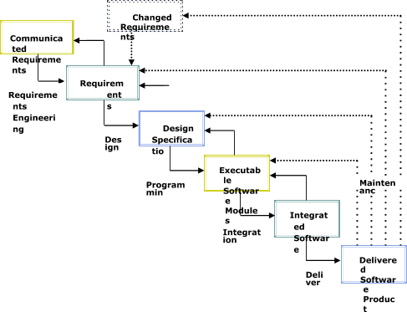

# Chapter

# OVERALL DESCRIPTION

**Project Perspective**

The main purpose of preparing this document is to give a general insight into the analysis and requirements of the existing system or situation and for determining the operating characteristics of the system

# Project Functions

# University Administrator :

It has the functionality of registering new colleges, universities and courses.

# College Administrator:

IThas the rights of creating department, allocating courses to departments, creating faculties, students and allocating subjects to faculties, and modifications in the data entered by the user can also be done by the college administrator.

**Users :**

It may be faculty or students. Faculty has the facility of entering the marks and attendance of the students. Students can check their marks and attendance but there is no chance of modifications.

# (a) DATA FLOW DIAGRAMS

A data flow diagram is a graphical tool used to describe and analyze the movement of data through a system. These are the central tool and the basis from which the other components are developed. The transformation of data from input to output, through processed, may be described logically and independently of physical components associated with the system. A full description of a system consists of a set of data flow diagrams. The process is further identified with a number that will be used for identification purpose. Each process in lower level diagrams can be broken down into a more detailed DFD in the next level.

The idea behind the explosion of a process into more process is that understanding at one level of detail is exploded into greater detail at the next level. This is done until the further explosion is necessary and an adequate amount of detail is described for an analyst to understand the process.

Larry Constantine first developed the DFD as a way of expressing system requirements in a graphical form, this lead to the modular design.

A DFD is also known as a “bubble Chart” has the purpose of clarifying system requirements and identifying major transformations that will become programs in system design

# DFD SYMBOLS:

In the DFD, there are four symbols

1. A square defines a source(originator) or destination of system data
2. An arrow identifies data flow. It is the pipeline through which the information flows
3. A circle or bubble represents a process that transforms incoming data flow into outgoing data flows.
4. An open rectangle is a data store, data at rest or a temporary repository of data

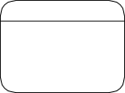 A process that transforms data flow.

 Source or Destination of data

 Data flow

 Data Store

# 

# CONSTRUCTING A DFD:

Several rules of thumb are used in drawing DFD’S:

1. The process should be named and numbered for an easy reference. Each name should be representative of the process.
2. The direction of flow is from top to bottom and from left to right. Data traditionally flow from source to the destination although they may flow back to the source. One way to indicate this is to draw a long flow line back to a source.
3. An alternative way is to repeat the source symbol as a destination. Since it is used more than once in the DFD it is marked with a short diagonal.

# TYPES OF DATA FLOW DIAGRAMS

1. Current Physical

2. Current Logical

3. New Logical

4. New Physical

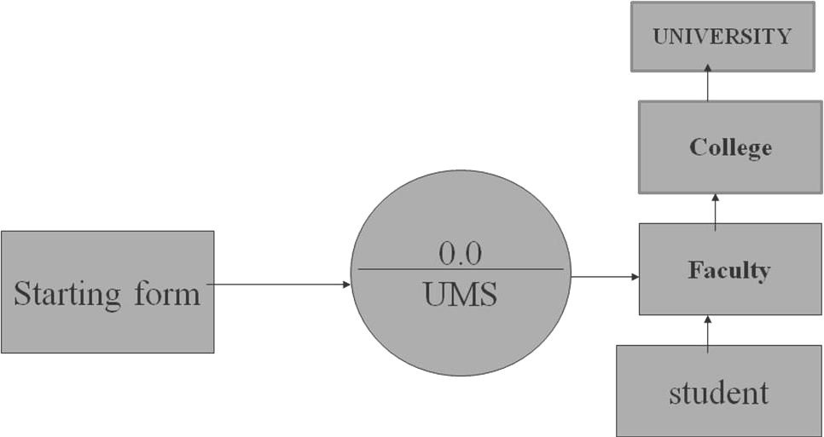

**2.1 Context Level (0th level DFD)**

**2.2 1st level DFD**

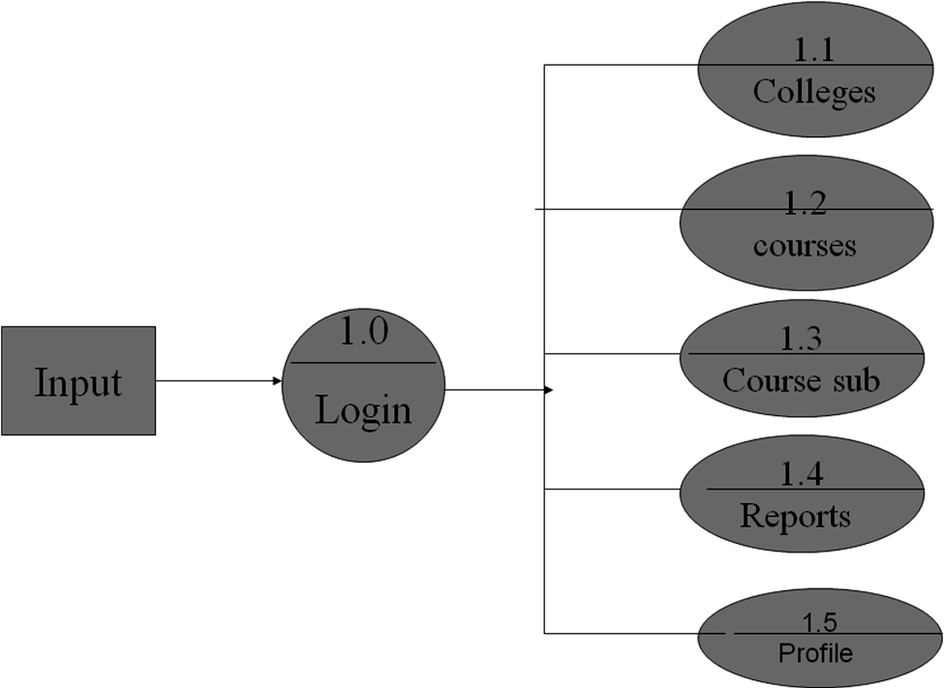

**2.3 College functionalities 2nd level**

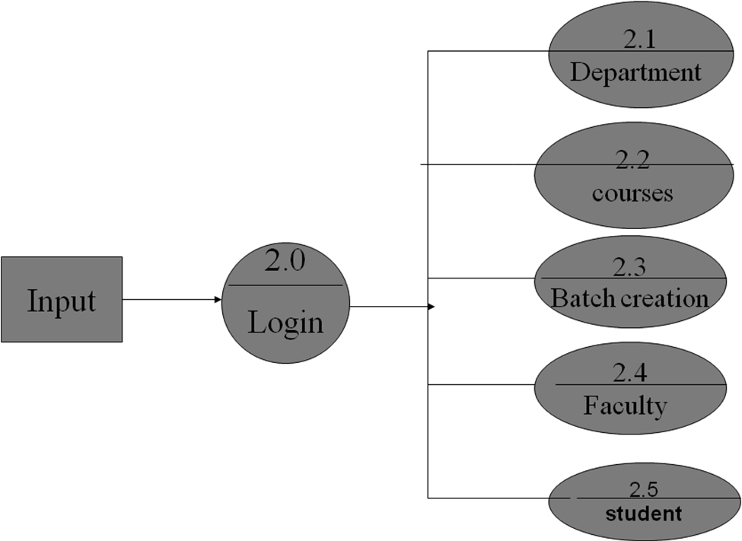

**2.4 Staff functionalities 3rd level**

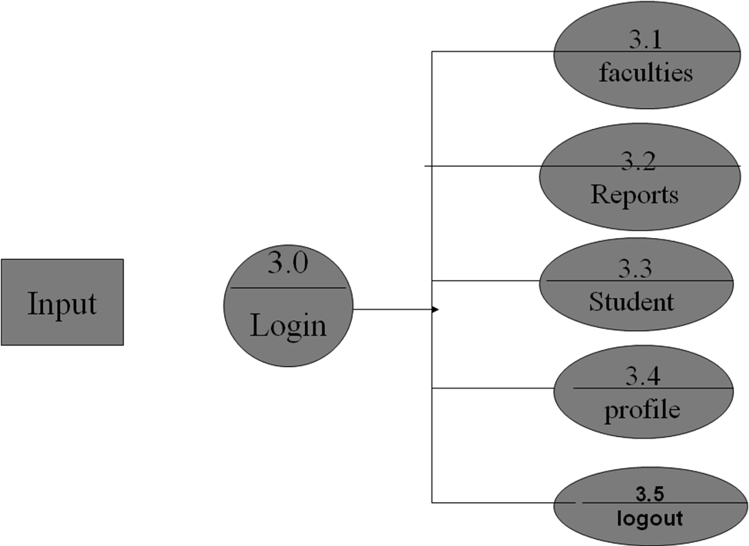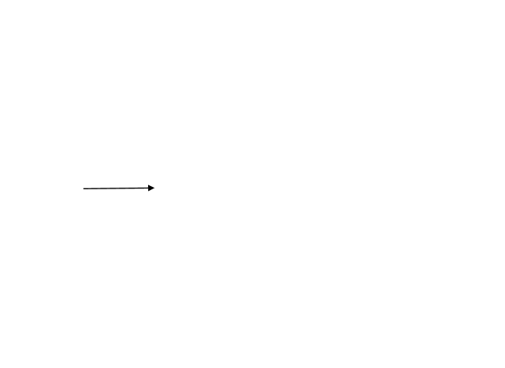

**2.5 Student functionalities 4th level**

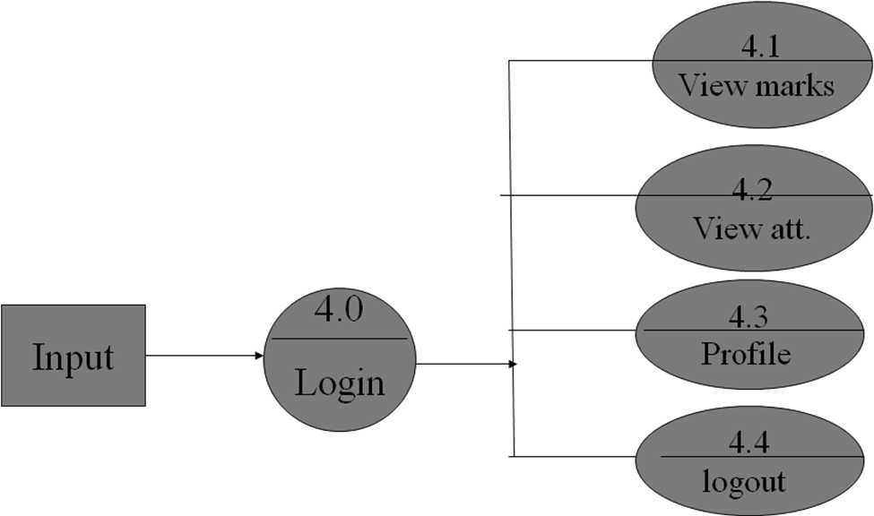

**2.3 (b) ER Diagrams**

The relation upon the system is the structure through a conceptual ER-Diagram, which not only specifics the existential entities but also the standard relations through which the system exists and the cardinalities that are necessary for the system state to continue.

The entity Relationship Diagram (ERD) depicts the relationship between the data objects. The ERD is the notation that is used to conduct the data modelling activity the attributes of each data object noted is the ERD can be described resign a data object descriptions.

* The set of primary components that are identified by the ERD are
* Data object
* Relationships
* Attributes
* Various types of indicators.

The primary purpose of the ERD is to represent data objects and their relationships

# Constraints and Assumptions through diagram for HOD:



Login

Assign Subjects to Faculties

College HOD

Give Marks

Give Attendance

Reports

Logout

**Constraints and Assumptions through diagram for student:**

Login

View Attendance

College Student

View Marks

Logout

# Constraints and Assumptions through diagram for Faculty:

Login



College Faculty

View Assigned Subjects

Give Marks

Logout

# Chapter 3

# METHODOLOGY

### IMPLEMENTATION METHODOLOGY:-

### MAIN PAGE:

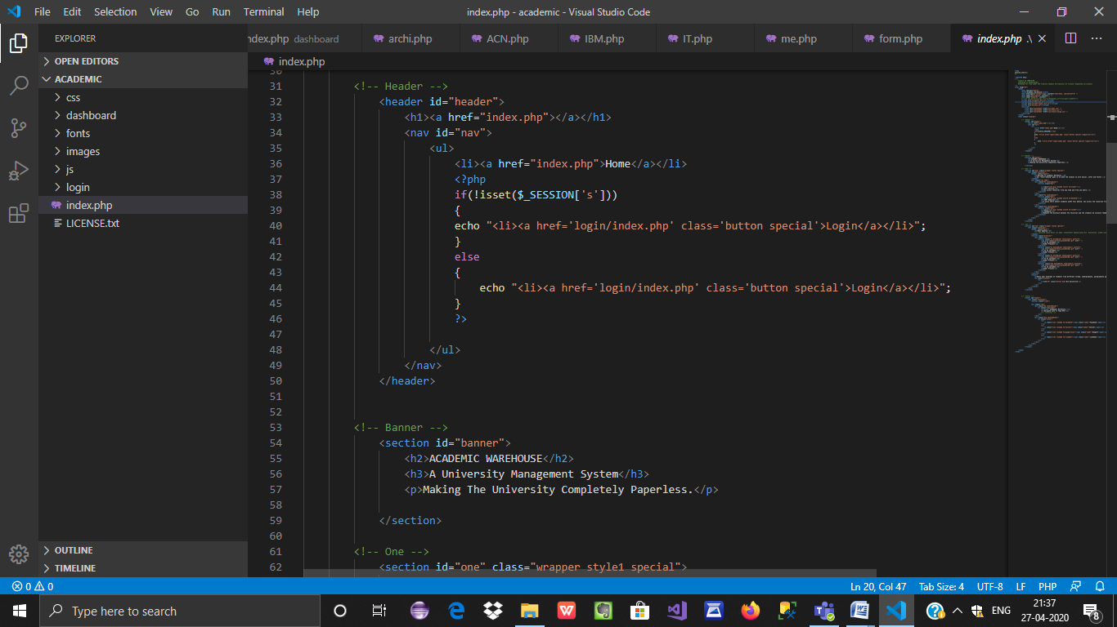

This page contains the basic interface of the website. It includes the title, header, description, login, footer, etc.

### LOGIN:

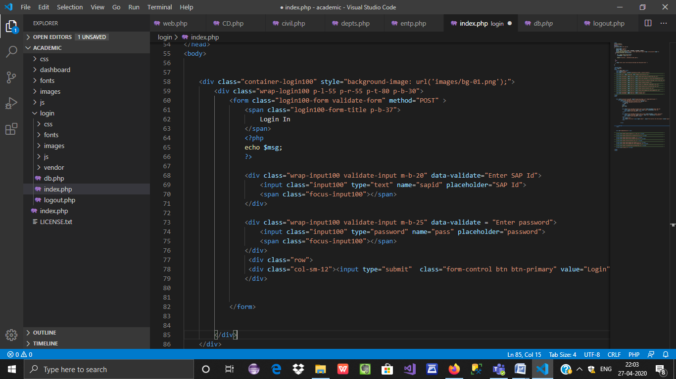

These set of codes are used for logging in to their particular account. At the starting, the code receives a login keyword from index.php page and thus login and create a session for that person.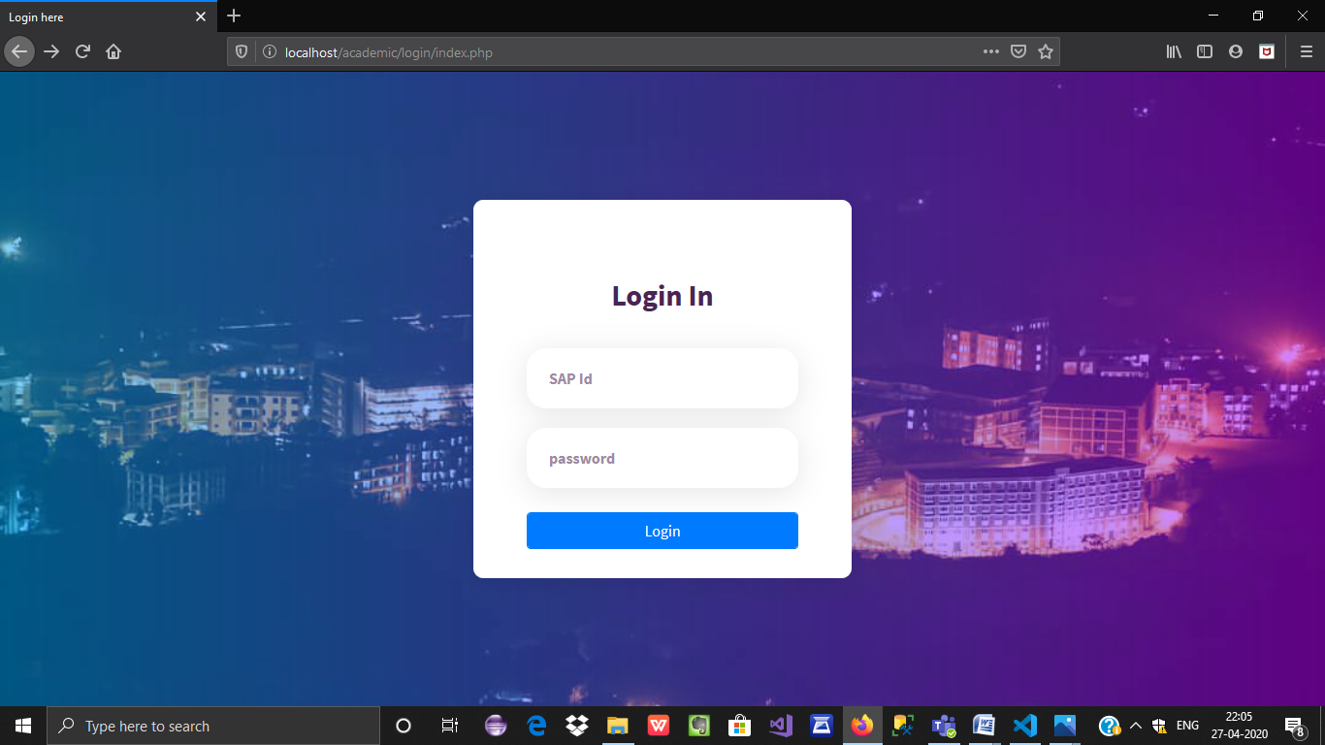

### DASHBOARD:

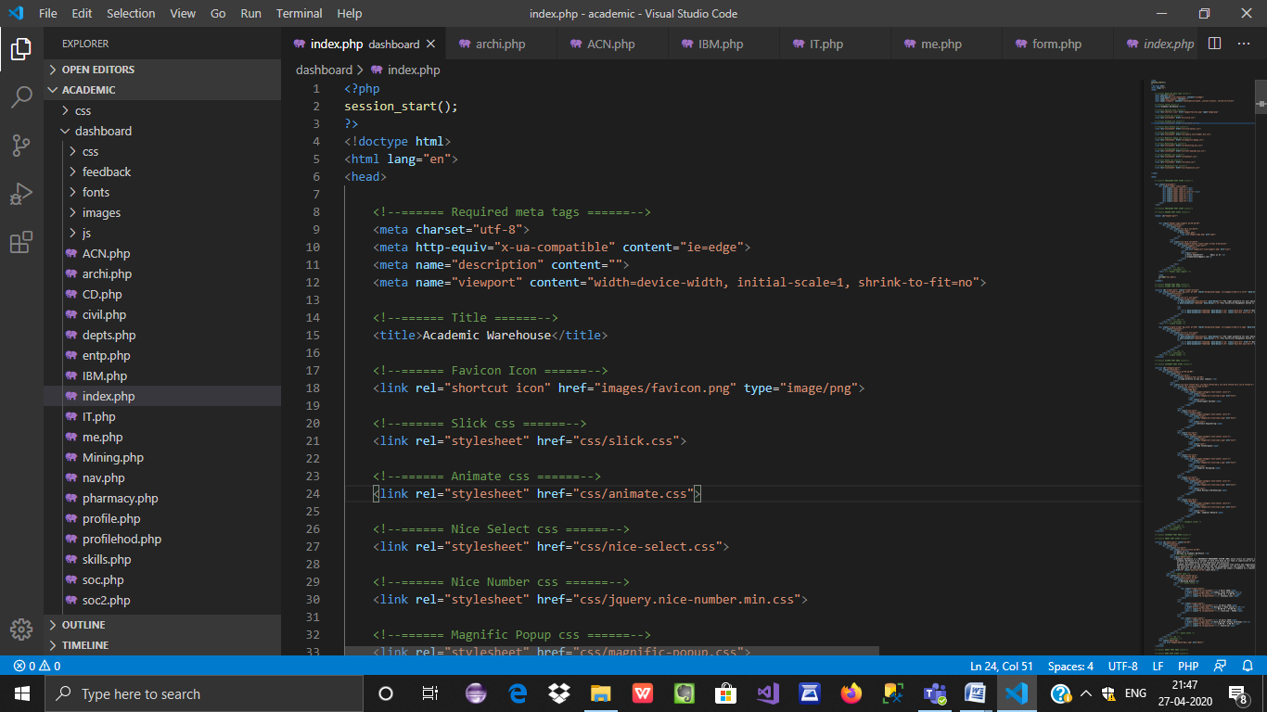



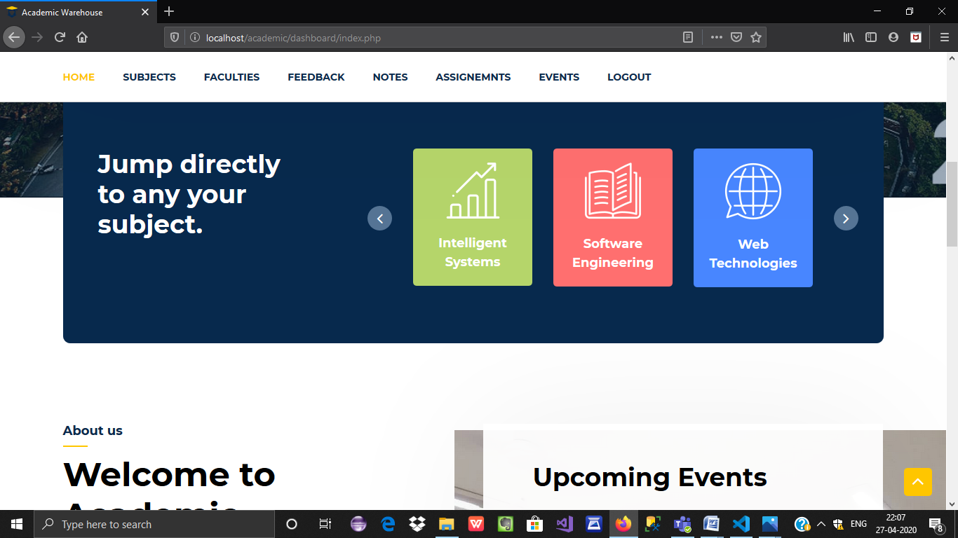

This is the main page of the dashboard of the student to which he/she will be directed after logging in where everything will be available from subjects, notes, assignments to every detail needed of any particular faculty. We also have the feedback form in which students can provide anonymous feedback for any class.

### DASHBOARD NAVIGATION BAR:

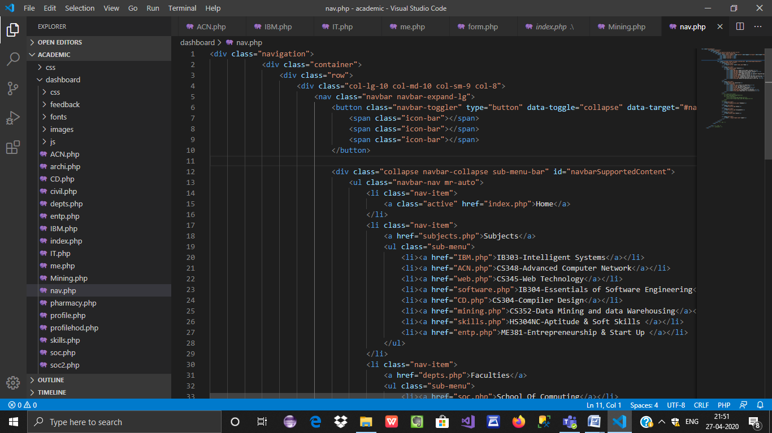



This is the navigation bar of the dashboard which is same in all the pages of the dashboard including Home, Subjects, Faculties, Feedback, Notes, Assignments, Events, Logout.

### SUBJECTS LIST:

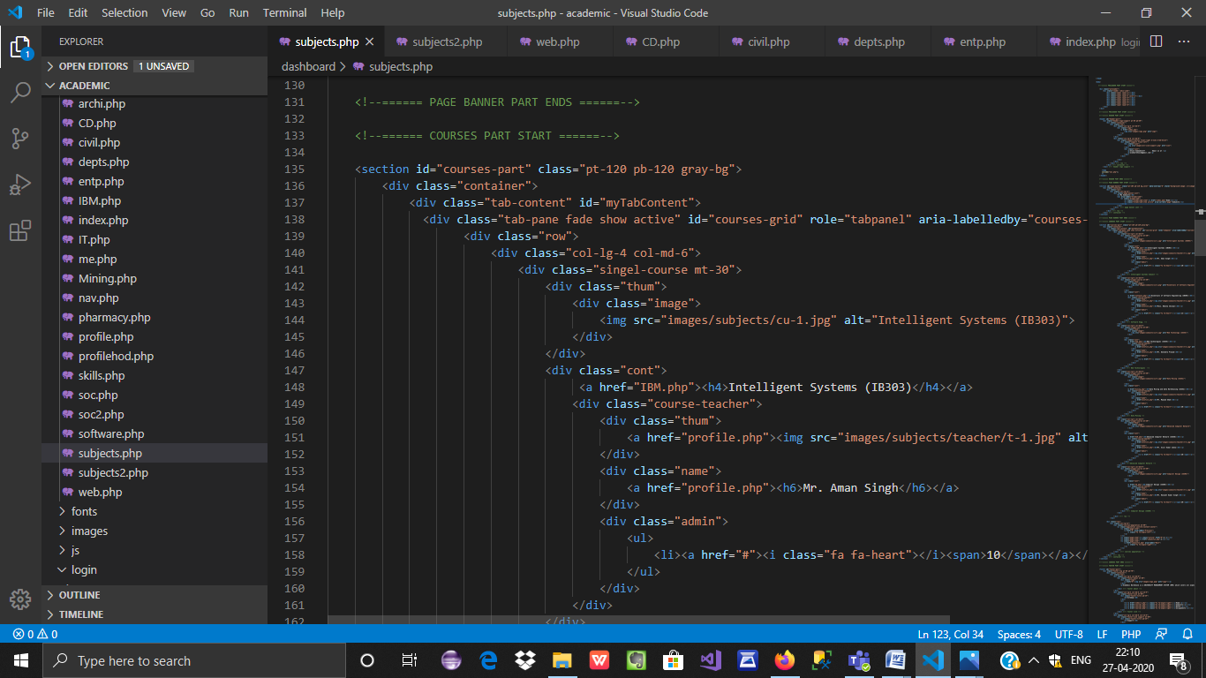

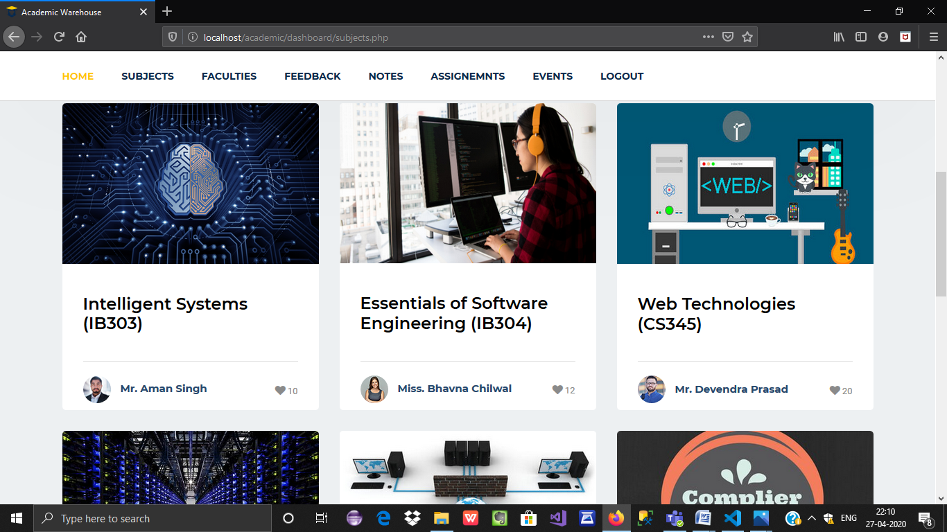

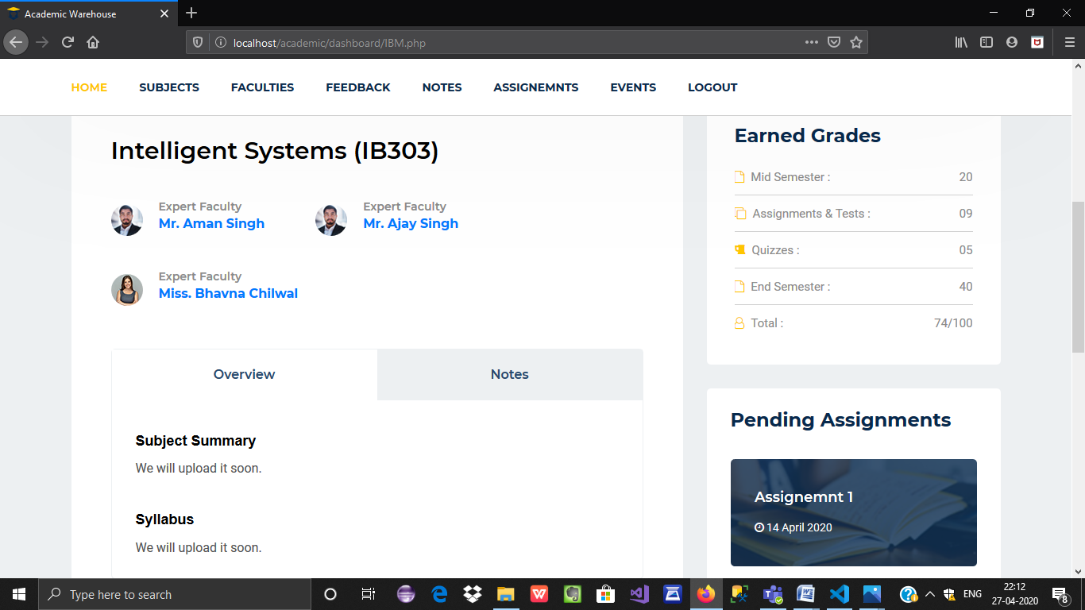

This represents the list of subjects with their subject code and clicking on any one subject would lead to its details such as all the faculties of that particular subject, pending assignments, syllabus, the earned grades, notes, etc.

### FACULTIES LIST:

### C:\Users\User-HP\Pictures\Screenshots\Screenshot (83).png

### C:\Users\User-HP\Pictures\Screenshots\Screenshot (82).png

### C:\Users\User-HP\Pictures\Screenshots\Screenshot (84).png

### C:\Users\User-HP\Pictures\Screenshots\Screenshot (85).png

This shows all the list of faculties in different departments, clicking on any department would lead to the faculties in that particular department and clicking on any particular faculty would lead to the further details of faculty like the classes which he/she teaches, the cabin number, e-mail id, free hours, etc.

### FEEDBACK FORM:

### C:\Users\User-HP\Pictures\Screenshots\Screenshot (86).png

This is the feedback form which would be available for the students to fill which would be anonymous for any faculty or any particular class.

### DATABASE CONNECTIVITY:

### C:\Users\User-HP\Pictures\Screenshots\Screenshot (87).png

This set of code helps to connect to the database which helps in the backend connectivity using MySQL.

# CHAPTER 4

# TECHNOLOGY USED

### WAMP SERVER

WampServer is a Web development platform on Windows that allows you to create dynamic Web applications with Apache2, PHP, MySQL and MariaDB. WampServer automatically installs everything you need to intuitively developed Web applications. You will be able to tune your server without even touching its setting files. Best of all, WampServer is available for free (under GPML license) in both 32 and 64-bit versions. Wampserver is not compatible with Windows XP, SP3, or Windows Server 2003.

#### Features

* + - Manage your Apache, MySQL and MariaDB services
    - Install and switch Apache, MySQL, MariaDB and PHP releases
    - Manages your servers settings
    - Access your logs
    - Access your settings files
    - Create alias
    - Used for VirtualHost as hosters

### HTML

Hypertext Markup Language (HTML) is the standard markup language for documents designed to be displayed in a web browser. It can be assisted by technologies such as Cascading Style Sheet (CSS) and Scripting Languages such as Javascript

The web browser receives HTML documents from a web server or local storage and renders the documents into multimedia web pages. HTML describes the structure of a web page semantically and originally included cues for the appearance of the document.

### CASCADING STYLE SHEET (CSS)

Cascading Style Sheets (CSS) is a style sheet language used for describing the presentation of a document written in a markup language like HTML. CSS is designed to enable the separation of presentation and content, including layout, colours, and fonts.

### JAVASCRIPT

JavaScript (often shortened to JS) is a lightweight, interpreted, object-oriented language with first-class function and is best known as the scripting language for Web pages, but it's used in many non- browser environments as well. It is a prototype-based, multi-paradigm scripting language that is dynamic, and supports object-oriented, imperative, and functional programming styles.

JavaScript runs on the client-side of the web, which can be used to design / program how the web pages behave on the occurrence of an event. JavaScript is easy to learn and also a powerful scripting language, widely used for controlling web page behaviour.

### PHP

PHP is an HTML-embedded server-side scripting language. Much of its syntax is borrowed from C, Java and Perl with a couple of unique PHP-specific features thrown in. The goal of the language is to allow web developers to write dynamically generated pages quickly.

### BOOTSTRAP

Bootstrap is a free and open-source CSS framework directed at responsive, mobile-first front-end web development. It contains CSS- and (optionally) JavaScript-based design templates for typography, forms, buttons, navigation, and other interface components.

# Chapter 5

## SYSTEM REQUIREMENTS

* 1. **External Interface Requirement**
     1. **Hardware requirements:**

|  |  |
| --- | --- |
| **Number** | **Description** |
| 1 | PC with 500 GB hard- disk  and 4 GB RAM |

* + 1. **Software requirements:**

|  |  |
| --- | --- |
| **Number** | **Description** |
| 1 | Windows 7 or Higher. |
| 2. | NetBeans IDE 8.0 or Higher |
| 3. | Wamp Server |
| 4. | Google Chrome/Mozilla Firefox |

# Chapter 6

# CONCLUSION AND FUTURE WORK

### CONCLUSION:-

It has been a great pleasure for me to work on this exciting and challenging project. This project proved good for me as it provided a practical knowledge of not only programming in javascript and web-based application and no some extent Windows Application and SQL Server, but also about all handling procedure related with “University Management system”. It also provides knowledge about the latest technology used in developing web-enabled application and client-server technology that will be great demand in future. This will provide better opportunities and guidance in future in developing projects independently.

BENEFITS:

It’s a web-enabled project. The project is identified by the merits of the system offered to the user. The merits of this project are as follows: -

* This project offers the user to enter the data through simple and interactive forms. This is very helpful for the client to enter the desired information through so much simplicity.
* The user is mainly more concerned about the validity of the data, whatever he is entering. There are checks on every stage of any new creation, data entry or updation so that the user cannot enter the invalid data, which can create problems at later date.
* Sometimes the user finds in the later stages of using a project that he needs to update some of the information that he entered earlier. There are options for him by which he can update the records. Moreover, there is a restriction for his that he cannot change the primary data field. This keeps the validity of the data to a longer extent.
* User is provided with the option of monitoring the records he entered earlier. He can see the desired records with a variety of options provided by him.
* From every part of the project, the user is provided with a number of links through framing so that he can go from one option of the project to other as per the requirement. This is bound to be simple and very friendly as per the user is concerned. That is, we can say that the project is user friendly which is one of the primary concerns of any good project.
* Data storage and retrieval will become faster and easier to maintain because data is stored in a systematic manner and a single database.
* Decision-making process would be greatly enhanced because of the faster processing of information since data collection from information available on the computer takes much less time than the manual system.
* Allocating of sample results becomes much faster because at a time the user can see the records of last years.
* Easier and faster data transfer through the latest technology associated with computer and communication.
* Through these features, it will increase the efficiency, accuracy and transparency

.

# FUTURE IMPROVEMENT

* It can be implemented to upload files with a huge amount of size with the support of various file formats.
* This System being web-based and an undertaking of the Cyber Security Division needs to be thoroughly tested to find out any security gaps.
* A console for the data centre may be made available to allow the person to monitor on the sites which were cleared for hosting during a particular period.
* The various functionalities of college like the cafeteria, hostel managements will be included.

Moreover, it is just a beginning; further, the system may be utilized in various other types of auditing operation viz. N

# REFERENCES AND BIBLIOGRAPHY

<http://www.javaworld.com/javaworld/><https://learncodeonline.in/>

<https://firebase.google.com/>

<https://www.javatpoint.com/android-sqlite-tutorial>

<https://www.tutorialspoint.com>